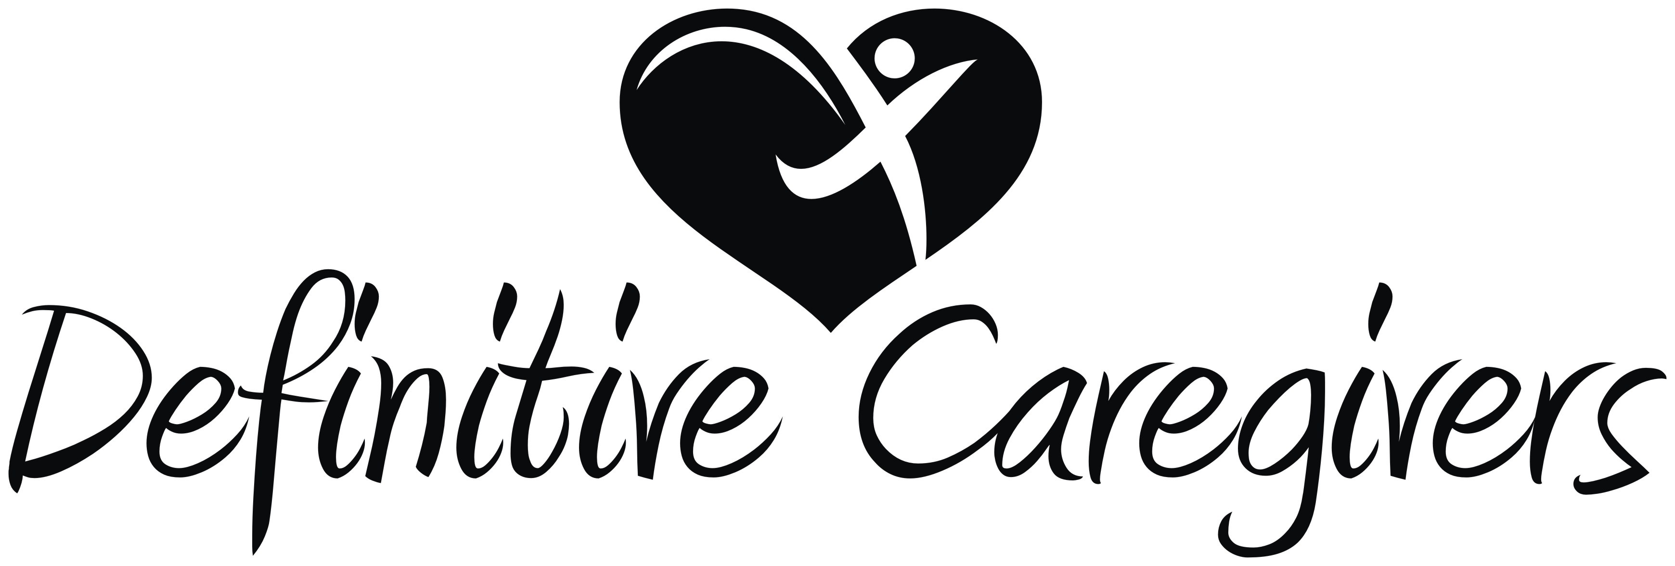Aide Skills Inventory

Date: Caregiver Name: CNA HHA
Please mark an X in the appropriate box next to each entry based on your experiences in patient care.

Skill | Experienced | Needs Review | Not Capable | Skill | Experienced | Needs Review | Not Capable
SPECIALTY CARE |  |  |  | PERSONAL CARE
Infant 0-2 yr |  |  |  | Tub Bath/Shower
Pediatric 2-13 yr |  |  |  | Bed Bath/Sponge Bath
Adolescent 13-18 yr |  |  |  | Hair Care
Adult |  |  |  | Oral/Mouth Care
Geriatric |  |  |  | Denture Care
Alzheimer’s/Dementia |  |  |  | Hearing Aids
Parkinson’s Disease |  |  |  | Skin Care/Grooming
Hospice Care |  |  |  | Shaving
Spinal Cord Injury |  |  |  | Nail Care
Brain/Head Injury |  |  |  | Foot Care
Stroke |  |  |  | Pressure Sore Precautions
Amputee |  |  |  | NUTRITION
Diabetes |  |  |  | Prepare/Serve Meals
Cardiac/Heart |  |  |  | Fluid Restrictions
Pulmonary/Respiratory |  |  |  | Assist with Feeding
HOMEMAKING |  |  |  | Intake/Output Readings
Laundry/Washer/Dryer |  |  |  | PEG Site Care
Dishes/Dishwasher |  |  |  | Swallow Precautions
Linens/Making Beds |  |  |  | UNIVERSAL PRECAUTIONS
Vacuum/Mop |  |  |  | Use of Protective Equipment
Garbage Disposal |  |  |  | Masks
Blender |  |  |  | Gloves
TRANSFERRING |  |  |  | Gowns/Aprons
Wheelchair |  |  |  | CPR Shields
Pivot |  |  |  | VITAL SIGNS
Repositioning |  |  |  | Temperature
Hoyer |  |  |  | Pulse
Slide Board |  |  |  | Respirations
DRESSING |  |  |  | Blood Pressure
Upper Body |  |  |  | TOILETING
Lower Body |  |  |  | Toilet Transfers
Sock Aids |  |  |  | Use of Bedside Commode
Shoe Horn |  |  |  | Use of Bedpan/Urinal
Immobilizers |  |  |  | Foley Cath Care
TEDHose/Elastic Stockings |  |  |  | Empty Ostomy
Orthopedic Devices |  |  |  | Use of Diapers/Depends
Prosthesis |  |  |  | AMBULATION
OTHER |  |  |  | Use of Gait Belt
Medication Reminders |  |  |  | Range of Motion
Weight/Scale |  |  |  | Weight-bearing Restrictions
Languages Spoken |  |  |  | Ambulation with Devices  (Cane, Walker, Crutches)
Languages Read/Write

